**Trip Link: Plan & Find a Buddy**

A Mini Project Report Submitted in the partial fulfillment of the requirements for the award of the degree of

**BACHELOR OF TECHNOLOGY**

**In**

**DEPARTMENT OF COMPUTER SCIENCE ENGINNERING**

**Or**

**DEPARTMENT OF COMPUTER SCIENCE AND INFORMATION TECHNOLOGY**

**By**

**Reeshmanth Chowdary D – 2320030321(Team Lead)**

**Sasank Reddy Y – 2320030209**

**Manaswi M – 2320030310**

Under the Esteemed Guidance of

**Dr. K. Swapnika**





**K L (Deemed to be) University**

**DEPARTMENT OF COMPUTER SCIENCE ENGINEERING**

**Or**

**DEPARTMENT OF COMPUTER SCIENCE AND INFORMATION TECHNOLOGY**



**Declaration**

The Mini Project Report entitled “**Trip Link: Plan & Find a Buddy**” is a record of Bonafide work of **Reeshmanth Chowdary D – 2320030321, Sasank Reddy Y – 2320030209, Manaswi M – 2320030310.** submitted in partial fulfillment for the award of B. Tech in Computer Science and Engineering (or) Computer Science and Information Technology to the K L University. The results embodied in this report have not been copied from any other departments/University/Institute.

**Reeshmanth Chowdary D – 2320030321**

**Sasank Reddy Y – 2320030209**

**Manaswi M – 2320030310**

**K L (Deemed to be) University**

**DEPARTMENT OF COMPUTER SCIENCE ENGINEERING**

**Or**

**DEPARTMENT OF COMPUTER SCIENCE AND INFORMATION TECHNOLOGY**



**CERTIFICATE**

This is certify that the mini project based report entitled “**Trip Link: Plan & Find a Buddy”** is a bonafide work done and submitted by **Reeshmanth Chowdary D – 2320030321, Sasank Reddy Y – 2320030209, Manaswi M – 2320030310.** in partial fulfillment of the requirements for the award of the degree of **BACHELOR OF TECHNOLOGY** in Department of Computer Science Engineering, K L (Deemed to be University), during the academic year **2024-2025.**

**Signature of the Supervisor**

**Signature of the HOD                                               Signature of the External Examiner**

**ACKNOWLEDGEMENT**

The success in this project would not have been possible but for the timely help and guidance rendered by many people. Our wish to express my sincere thanks to all those who has assisted us in one way or the other for the completion of my project.

Our greatest appreciation to my guide, **Dr. K. Swapnika**, Department of Computer Science which cannot be expressed in words for his/her tremendous support, encouragement and guidance for this project.

We express our gratitude to **Dr. Ramesh Babu Sir (CSE)/Dr. Kaja Shareef Sir (CSIT)**, Head of the *Department for Computer Science Engineering****/*** *Department for Computer Science and Information Technology* for providing us with adequate facilities, ways and means by which we are able to complete this project-based Lab.

We thank all the members of teaching and non-teaching staff members, and also who have assisted me directly or indirectly for successful completion of this project. Finally, I sincerely thank my parents, friends and classmates for their kind help and cooperation during my work.

**Reeshmanth Chowdary D – 2320030321**

**Sasank Reddy Y – 2320030209**

**Manaswi M – 2320030310**

**TABLE OF CONTENTS**

|  |  |  |
| --- | --- | --- |
| **S.No** | **Contents** | **Page no.** |
| 1. | Abstract | 06 |
|  |  |  |
| 2. | Introduction | 07 |
| 3. | Literature survey | 08 |
| 4. | Problem Domain & Statement | 10 |
| 5. | Stakeholders’ meetings | 13 |
| 6. | Hardware and Software requirements | 39 |
| 7. | Implementation | 40 |
| 8. | Results & Discussion | 42 |
| 9. | Conclusion & Future Scope | 45 |
| 10. | References | 46 |

1. **ABSTRACT**

**Trip Link: Plan & Find a Buddy** is an AI-powered travel planning application designed to enhance solo travel experiences by integrating intelligent trip planning with a traveler-matching system. Built with a Swing-based UI, the application provides an interactive and user-friendly interface for planning and managing trips efficiently.

Using the Gemini API, TripLink generates personalized itineraries based on user inputs, including destination, budget, and travel dates. Trip details are securely stored in a PostgreSQL database via JDBC, allowing users to retrieve and review their plans anytime using a unique trip key. The clipboard copy feature simplifies sharing and accessing trip keys for quick retrieval.

One of the standout features is Solo Traveler Matching, which helps users connect with like-minded travelers. If multiple users choose the matching option and share the same destination and travel dates, they are notified and given the option to connect via email. Additionally, an End Trip & Delete feature ensures that users can manage and remove trip details when needed.

By combining AI-driven trip planning, database-backed trip management, and social connectivity, TripLink offers a seamless and engaging way to explore new destinations while finding potential travel companions.

**Team Name:** **Trip Link Innovators**

**Team Logo (if any):**



**Team Members:**

1. Reeshmanth Chowdary D,2320030321
2. Sasank Reddy Y,2320030209
3. Manaswi M,2320030310
4. **INTRODUCTION**

In today's digital age, solo travelers often face challenges in both **trip planning** and **finding suitable travel companions**. Traditional trip planning methods can be time-consuming, and traveling alone may feel isolating. **TripLink Innovators** aims to address these challenges by developing **TripLink: Plan & Find a Buddy**, an AI-powered travel planning and matching application.

This project integrates **intelligent trip planning** with **solo traveler matching**, allowing users to generate personalized trip plans using the **Gemini API** while also connecting with like-minded travelers based on destination and travel dates. The application is built with a **Swing-based UI** for an interactive experience and utilizes **PostgreSQL with JDBC** for secure trip storage and retrieval using unique trip keys. Additionally, users can copy their trip keys to the clipboard for easy access and manage their plans with an **End Trip & Delete feature**.

By combining **AI-driven itinerary creation, database-backed trip management, and social connectivity**, this project enhances the solo travel experience, making it more convenient, engaging, and connected. The following sections will provide a detailed overview of the system's features, architecture, and implementation.

1. **LITERATURE SURVEY**

**Introduction to Solo Travel and Its Challenges**

Solo travel has become increasingly popular in recent years, as individuals seek freedom and self-discovery while exploring new destinations. However, despite the excitement, solo travelers face a range of challenges, including the complexity of planning their trips and the feeling of isolation when traveling alone. Traditional trip planning methods can be cumbersome, and finding like-minded travel companions can be difficult. Addressing these issues requires innovative solutions that combine intelligent technology with social connectivity.

**AI-Driven Travel Planning**

AI-powered travel planning systems have been explored in various domains, including itinerary generation, budget management, and personalized recommendations. These systems leverage user inputs such as destination, budget, travel dates, and personal preferences to generate tailored trip plans. AI can improve decision-making by analyzing vast amounts of data, considering user preferences, and adapting to changes in real time. In the context of solo travel, AI can offer a personalized experience that alleviates the stress of planning and ensures that travelers' needs are met in a streamlined way.

One prominent approach involves using APIs to integrate external services, such as the Gemini API, which allows developers to leverage AI for dynamic itinerary generation based on user inputs. This has proven to be a valuable tool for trip planners, as it enhances the quality of recommendations and simplifies the trip planning process.

**Database Integration for Trip Management**

Database integration plays a crucial role in managing trip data efficiently. Storing trip details in a relational database like PostgreSQL ensures that user data is organized, secure, and accessible. The use of JDBC (Java Database Connectivity) facilitates seamless communication between the application and the database, enabling the retrieval and storage of trip information using unique trip keys.

For applications like TripLink, which involve multiple user inputs and need to store sensitive data securely, utilizing relational databases helps maintain data integrity and provides the flexibility needed for future scalability. Additionally, allowing users to retrieve and manage their trip plans via unique keys offers convenience and a personalized experience.

**Social Connectivity in Solo Travel**

One of the most significant innovations in TripLink: Plan & Find a Buddy is the Solo Traveler Matching feature. This aspect of the application helps solo travelers connect with others who share the same destination and travel dates. Research shows that social connections can significantly enhance the solo travel experience by reducing feelings of loneliness and providing opportunities for shared experiences. Traveler matching systems are emerging in various travel-related applications, facilitating interactions based on common interests and travel goals.

Incorporating a feature where users are notified and given the option to connect via email when they share similar travel plans is a practical approach to fostering these connections. This not only enriches the travel experience but also provides opportunities for collaborative exploration, making solo travel more enjoyable and socially engaging.

**User Interface and Experience (UI/UX)**

The user interface (UI) is an essential part of any application, especially in the travel domain, where ease of use is paramount. Swing-based UIs have been widely used in Java applications due to their flexibility, ease of implementation, and ability to create visually interactive components. A Swing-based UI provides a simple and effective way to display various trip-related details, such as input forms, generated trip plans, and matching traveler notifications.

An intuitive UI design that allows users to easily input their trip information, review plans, and manage their travel details is crucial for enhancing the user experience. The ability to access trip keys through a clipboard copy feature and manage trips with an End Trip & Delete option further adds to the convenience, ensuring that users have full control over their trip management.

**Integrating AI, Database, and Social Connectivity for Enhanced Travel Experiences**

Combining AI-driven trip planning, secure database-backed management, and social connectivity creates a holistic approach to solo travel. The integration of these technologies enables TripLink to provide users with not only personalized itineraries but also an opportunity to connect with other travelers. The system can serve as a virtual travel companion, offering suggestions and enabling social interaction while alleviating the challenges of solo travel.

The ability to generate tailored itineraries, store trip data securely, and connect with other solo travelers using matching algorithms presents an innovative approach to modern travel. This combination of features allows for a richer, more connected solo travel experience, where travelers can seamlessly plan their trips and find companionship along the way.

1. **Problem/Opportunity Domain**

**Domain of Interest: Tourism**

**Description of the Domain:**

The tourism industry plays a pivotal role in economic growth, offering numerous opportunities for innovation. Challenges include enhancing travel experiences, streamlining trip planning, and improving social connectivity among solo travelers. This domain is ripe for developing digital solutions that provide personalized itineraries, foster social connections, and integrate emerging technologies like AI for optimized trip management.

**Why did you choose this domain?:**

The tourism industry has immense growth potential, and the idea of improving solo travel experiences through technology aligns with my passion for creating meaningful solutions that bridge gaps in travel. The increasing demand for personalized services makes this a strategic domain for innovation.

**Problem/Opportunity Statement**

**Problem Statement:**

Solo travelers face challenges in trip planning and finding suitable travel companions, which can lead to frustration and isolation.

**Problem Description:**

Planning a solo trip is time-consuming and often overwhelming, while finding like-minded travelers to share experiences with is difficult. Existing solutions are either complicated or fail to offer social connectivity for solo travelers.

**Context (When does the problem occur):**

The problem arises when solo travelers attempt to plan their trips, whether for leisure, adventure, or personal growth, without the support of personalized guidance or opportunities for companionship.

**Alternatives (What does the customer do to fix the problem):**

Travel agencies, social media groups, and online travel forums are used, but they often lack personalization, real-time updates, or structured connections with fellow travelers.

**Customers (Who has the problem most often):**

Primarily solo travelers, digital nomads, and individuals seeking personalized, independent travel experiences.

**Emotional Impact (How does the customer feel):**

Travelers may feel overwhelmed, stressed, and isolated when trying to plan trips, leading to frustration and anxiety about missing out on social connections.

**Quantifiable Impact (What is the measurable impact):**

Increased time spent on planning (hours to days), lost opportunities for better trip experiences, and dissatisfaction with social isolation during travel.

**Alternative Shortcomings (What are the disadvantages of the alternatives):**

Current solutions often fail to combine efficient trip planning with social connectivity, resulting in fragmented experiences that don’t fully cater to the needs of solo travelers.

**Any Video or Images to showcase the problem:**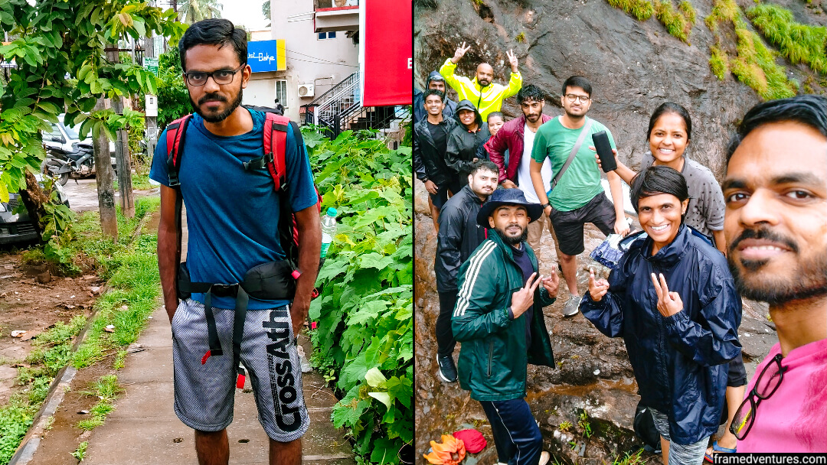

[**https://www.youtube.com/watch?v=_Is_fbuLP6I**](https://www.youtube.com/watch?v=_Is_fbuLP6I)

**Addressing SDGs**

**Relevant Sustainable Development Goals (SDGs):**

**SDG 8 – Decent Work and Economic Growth**

TripLink supports sustainable tourism, which promotes economic growth by making travel more accessible and connected. By improving solo travel experiences, it contributes to the tourism industry’s development and enhances job opportunities within the sector



**How TripLink Addresses SDG 8 – Decent Work and Economic Growth**

TripLink enhances the tourism industry by making travel more accessible, engaging, and connected. By improving solo travel experiences, it encourages more people to explore new destinations, leading to increased tourism revenue and local economic growth. Additionally, by integrating AI-driven planning and traveler matching, the platform supports sustainable tourism, creating opportunities for businesses, tour guides, and local services.

This aligns with SDG 8, which promotes sustained, inclusive, and sustainable economic growth, fostering employment opportunities in the travel and tourism sector.

1. **STAKEHOLDERS’ MEETINGS**

Answer these below questions to understand the stakeholder related to your project

**1. Who are the key stakeholders involved in or affected by this project?**

* **Solo travelers** – The primary users who benefit from AI-driven trip planning and traveler matching.
* **Travel agencies & tour operators** – Potential partners who can offer services through the platform.
* **Hospitality & tourism businesses** – Hotels, restaurants, and local guides who may see increased bookings.
* **Government tourism boards** – Entities promoting sustainable tourism and economic growth.
* **Investors & funding organizations** – Those providing financial support for development and expansion.

**2. What roles do the stakeholders play in the success of the innovation?**

* **Solo travelers** drive adoption and feedback for platform improvement.
* **Travel agencies & tourism businesses** can collaborate by offering exclusive deals.
* **Government tourism boards** can provide data, support, and potential funding.
* **Investors** help scale and sustain the project financially.

**3. What are the main interests and concerns of each stakeholder?**

* **Solo travelers** – A seamless, secure, and engaging trip-planning experience.
* **Travel agencies & tourism businesses** – Increased customer reach and revenue growth.
* **Government bodies** – Ensuring compliance with tourism regulations and promoting safe travel.
* **Investors** – Return on investment (ROI) and scalability of the platform.

**4. How much influence does each stakeholder have on the outcome of the project?**

* **High influence:** Solo travelers, investors, and government bodies.
* **Moderate influence:** Travel agencies and tourism businesses.

**5. What is the level of engagement or support expected from each stakeholder?**

* **Solo travelers** – Continuous engagement through app usage and feedback.
* **Tourism businesses & agencies** – Collaborations for promotions and discounts.
* **Government bodies** – Potential funding and regulatory support.

**6. Are there any conflicts of interest between stakeholders? If so, how can they be addressed?**

* **Conflict:** Traditional travel agencies may view AI trip planning as competition.
  + **Solution:** Position TripLink as a complementary tool that enhances their services.
* **Conflict:** Privacy concerns regarding user data and traveler matching.
  + **Solution:** Implement strong data protection policies and allow opt-in for traveler matching.

**7. How will you communicate and collaborate with stakeholders throughout the project?**

* **Solo travelers** – Surveys, in-app feedback, and community forums.
* **Business partners** – Formal partnerships, periodic meetings, and API integrations.
* **Government & investors** – Progress reports, presentations, and funding proposals.

**8. What potential risks do stakeholders bring to the project, and how can these be mitigated?**

* **Low user adoption** – Address through effective marketing and UX improvements.
* **Privacy concerns** – Implement strict data security measures.
* **Regulatory issues** – Ensure compliance with tourism and data protection laws.
* **Investor dependency** – Diversify funding sources to avoid financial instability.

**Meeting Schedule and Reports**

**1. First Meeting: Solo Traveler (Priya , Frequent Backpacker)**

**Geotag Photo:**

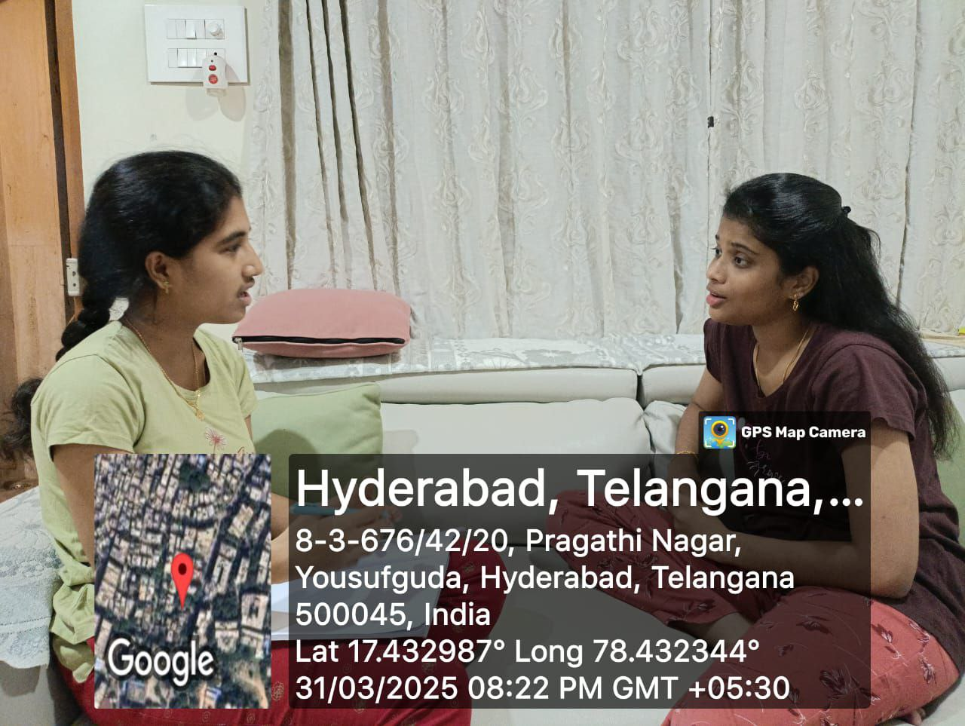

**Questions Asked:**

1. What are the biggest challenges solo travelers face when planning trips?
2. How do you currently find travel companions, if at all?
3. Would an AI-powered travel planner help streamline your trip planning process?
4. What features would you find most valuable in such an application?
5. Are you concerned about privacy when sharing travel details with others?

**Summary:**

Solo travelers struggle with planning and finding reliable travel companions. Existing solutions like social media groups lack personalization and security. A well-structured AI-powered travel planner with built-in traveler matching could significantly enhance their experience.

**2. Second Meeting: Travel Agency Representative(Rakesh M, Manager at Wander Travels)**

**Geotag Photo:**

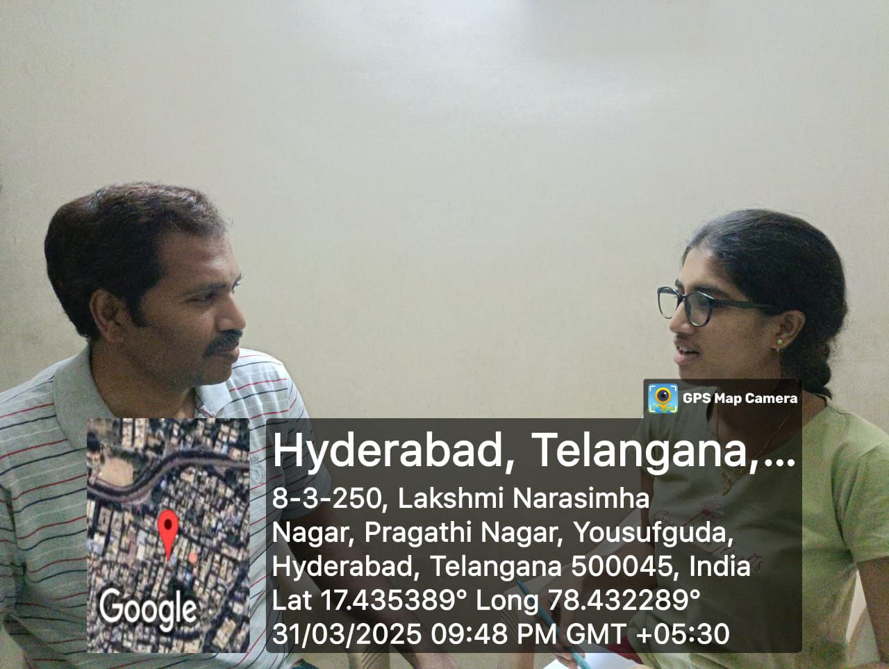

**Questions Asked:**

1. As a travel agency, what challenges do you face in reaching solo travelers?
2. Would you be open to partnering with a platform that connects travelers to your services?
3. What kind of offers or packages would attract solo travelers?
4. How important is AI and automation in modernizing travel services?
5. What concerns do you have about integrating with a platform like TripLink?

**Summary:**

Travel agencies struggle to attract solo travelers but are willing to collaborate if the platform allows them to offer tailored deals. AI-based automation is seen as a valuable tool in modern travel services.

**3. Third Meeting: Group of Travelers (Solo & Group Travelers Meetup)**

**Geotag Photo:**

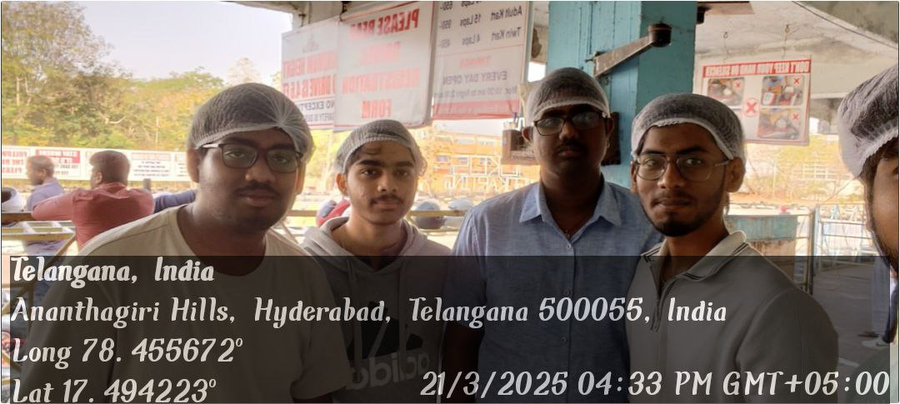

**Questions Asked:**

1. How do you currently plan your trips?
2. What are the biggest challenges you face while traveling solo?
3. Would you use an AI-powered platform for trip planning and traveler matching?
4. What features would make such an app useful for you?
5. How do you currently meet other travelers during your trips?

**Summary:**

The travelers found AI-based trip planning and matching an exciting idea. They struggle with reliable information, safety, and finding companions, making an AI-powered solution highly valuable. A structured, verified way to connect with other solo travelers would be a game-changer in improving the travel experience.

**4. Fourth Meeting: Investor (Ramya, Angel Investor in Travel Tech Startups)**

**Geotag Photo:**

**

**Questions Asked:**

1. As an investor, what factors make a travel-based AI project attractive?
2. What metrics would you look for to determine the success of such an application?
3. What are the risks associated with funding AI-driven travel startups?
4. How can we ensure scalability and long-term sustainability of the platform?
5. What additional revenue models could be integrated into the app?

**Summary:**

Investors are interested in AI-driven travel solutions if they show strong market demand and scalable business models. A mix of free and premium features can help sustain long-term growth.

**Power Interest Matrix of Stakeholders**

**Power Interest Matrix:**

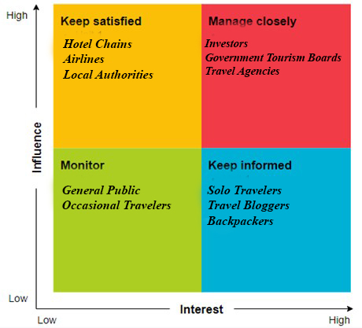

* **High Power, High Interest:** Investors, Government Tourism Boards, Travel Agencies
* **High Power, Low Interest:** Hotel Chains, Airlines, Local Authorities
* **Low Power, High Interest**: Solo Travelers, Travel Bloggers, Backpackers
* **Low Power, Low Interest:** General Public, Occasional Travelers

**Empathetic Interviews**

**Conduct Skilled interview with at least 30 citizens/Users by asking open ended questions (What, why/How etc) and list the insights as per the format below**

|  |  |  |
| --- | --- | --- |
| **I need to know**  **(thoughts, feelings, actions)** | **Questions I will ask**  **(open questions)** | **Insights I hope to gain** |
| Thoughts | What do you find most difficult about planning a solo trip? | Identify common pain points that travelers face in their trip planning. |
|  | How do you currently organize and plan your travel itinerary? | Understand the existing methods and tools used by travelers. |
|  | What are your thoughts on using AI to help plan trips or match with other solo travelers? | Gauge user openness to AI solutions in trip planning. |
| Feelings | How do you feel when you’re traveling alone? | Understand the emotional aspect of solo travel (e.g., excitement, loneliness, freedom). |
|  | What are the biggest worries you have while traveling solo? | Explore any anxiety or concerns users might have, such as safety or logistics. |
|  | How do you feel about meeting other solo travelers or strangers on your trips? | Assess user sentiment regarding meeting new people and forming connections. |
| actions | What steps do you take when your travel plans don’t go as expected? | Understand how users manage disruptions or unforeseen changes during travel. |
|  | How do you usually meet other travelers while on a trip? | Identify user actions related to networking and meeting people while traveling. |
|  | How do you decide on accommodations or travel services? | Explore behavior in booking decisions, such as price sensitivity, review-based choices, and preference for safety. |

**SKILLED INTERVIEW REPORT**

|  |  |  |
| --- | --- | --- |
| **User/Interviewee** | **Questions Asked** | **Insights gained (NOT THEIR ANSWERS)** |
| Vamshi, Student | What do you find most difficult about planning a solo trip? | Solo travelers often struggle with creating personalized itineraries and finding reliable travel companions. |
| Murali Krishna, Parent | What are your main concerns when traveling with family? | Parents prioritize safety, cost-efficiency, and family-friendly accommodations. They also prefer guided trip planning tools for ease. |
| Anjali, Solo Traveler | How do you usually plan your solo trips? | Solo travelers tend to rely on a mix of online resources (travel blogs, forums, social media) but are looking for a more streamlined, personalized way to plan trips. |
| Rajeev Kumar, Working Professional | What challenges do you face while planning work-related travel? | Professional travelers struggle with balancing personal preferences and work constraints when planning trips, often requiring a flexible and efficient trip planning system. |
| Neha, College Student | How do you feel about meeting fellow travelers during your trips? | Younger travelers are enthusiastic about connecting with like-minded individuals but emphasize the need for safe, trustworthy platforms. |

**Key Insights Gained:**

**Insight 1:** Solo travelers are highly interested in a personalized, AI-driven platform that offers tailored itineraries and helps connect them with trusted travel companions.

**Insight 2:** Travelers, especially parents and retirees, prioritize safety and security features in travel tools, such as verified accommodations and emergency assistance.

**Insight 3:** There’s a strong demand for flexible, easy-to-use platforms that cater to different travel preferences, whether it’s for work, leisure, or family travel.

**Insight 4:** Solo travelers often feel the need for a more structured and secure environment to meet like-minded individuals during their trips, especially outside traditional social media networks.

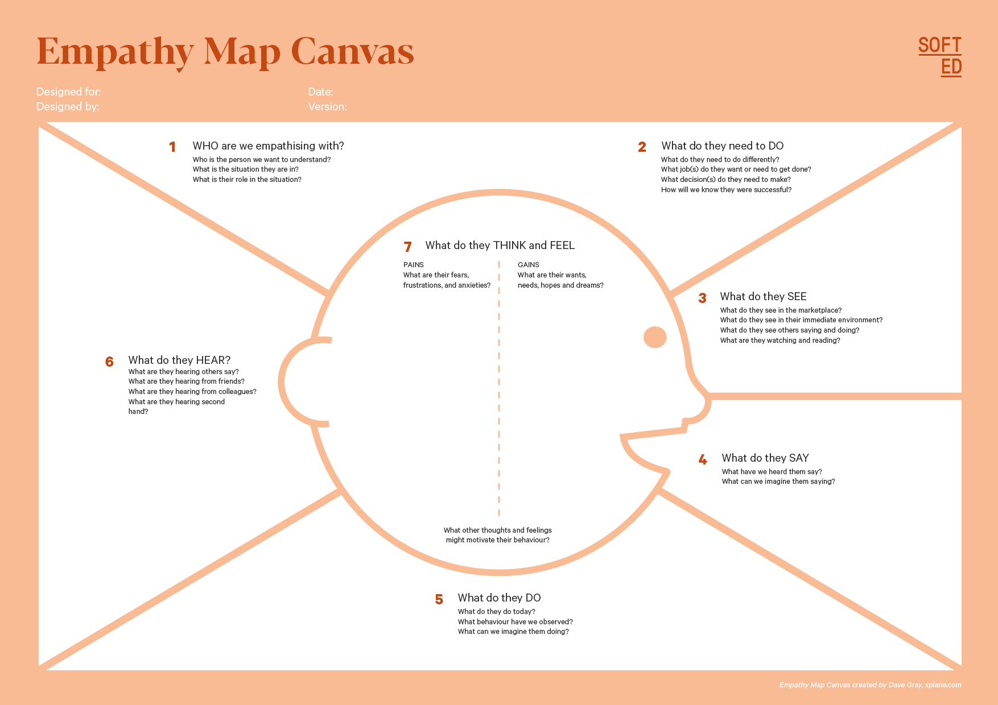

"Solo travel is amazing, but it's also risky."

"There are plenty of online tools, but none are tailored to my needs."

"You should try using this app; it helped me with my last trip."

Solo travelers, particularly **young adults** aged 18-35, who seek personalized, safe, and efficient ways to plan their travels while potentially connecting with like-minded individuals.

Who is your Customer:

Solo Travelers

Segment: Young Adults

Idea/Innovation Title:

AI-Powered Solo Travel Planning & Matching Platform

Designed By: Reeshmanth Chowdary D

Date of Submission: 2/04/2025

They feel **excited** about exploring new places but **anxious** about the safety and logistical aspects of solo travel. They often feel **overwhelmed** by the number of choices and lack a sense of security when meeting other travelers.

They think, "I wish there was a more streamlined and safe way to plan and meet others on my trips."

They are motivated by a desire for **independence**, **safety**, and **connection** with like-minded travelers while exploring new places.

They need to plan their trips efficiently, find reliable travel companions, ensure safety while traveling alone, and have access to personalized itineraries.

They see many travel options, social media platforms, and booking sites, but struggle to find a reliable, integrated tool for trip planning and connecting with other solo travelers in a safe environment.

"I want a more personalized trip."

"I don’t feel safe meeting strangers during my travels."

"I wish I could find like-minded travelers easily."

They research online, book flights and accommodations, join travel forums and social media groups, and look for recommendations from other travelers. They also use apps and websites but still feel something is missing.

**Empathy Map**

**a. Who is your Customer?**

**Description:**

* **Customer Profile:** Solo travelers aged 18-35, primarily from urban areas, seeking adventure, independence, and new experiences. They are tech-savvy and use digital tools to plan and book their travels.
* **Goals and Needs:**
  + Personalization in trip planning, secure accommodations, social connectivity with like-minded travelers.
  + Safety features to ensure peace of mind while traveling alone.
  + Efficient trip management and easy access to new travel experiences.
* **Context:**
  + The user will interact with an AI-driven travel app that helps plan trips, connect with fellow travelers, and ensure safety and convenience while traveling.

**b. Who are we empathizing with?**

**Description:**

* **User Characteristics:**
  + Independent, adventurous, and curious individuals.
  + Strong interest in exploring new destinations but worried about safety, finding travel companions, and managing the logistics of solo travel.
* **User’s Goals and Challenges:**
  + **Goals:** Personalized itineraries, safe travel environment, social connections with other solo travelers.
  + **Challenges:** Anxiety about meeting strangers, finding reliable travel information, and the difficulty of planning without local insights.
* **Broader Situation:**
  + They are students, young professionals, or freelancers, living in urban areas, and often travel for both leisure and work.

**c. What do they need to DO?**

**Description:**

* **Tasks/Actions:**
  + Plan personalized itineraries.
  + Search for accommodation and activities that meet their preferences.
  + Find and connect with other travelers with similar destinations and dates.
* **Decisions:**
  + Choosing destinations, accommodations, travel dates, and companions.
  + Deciding whether to share trip plans with others for socializing or safety.
* **Success/Failure:**
  + **Success:** Smooth, enjoyable trip with a well-organized itinerary and safe travel experiences.
  + **Failure:** Missed experiences, lack of connections with others, safety concerns.

**d. What do they SEE?**

**Description:**

* **Environment:**
  + Digital platforms like travel blogs, forums, and social media filled with mixed information about destinations.
  + A variety of travel apps that don’t offer personalized or safe ways to connect with fellow travelers.
* **Trends/Competitors:**
  + Social media platforms, other travel apps, and local tourism promotions.
  + Competitors often fail to integrate personalized travel planning with safety and social connectivity.
* **Influence:**
  + Visuals and influencers on social media shape their travel dreams, but they struggle with finding trustworthy and comprehensive planning solutions.

**e. What do they SAY?**

**Description:**

* **Expressions:**
  + “I wish there was an easier way to plan a trip and meet people who share my interests.”
  + “I feel anxious about traveling alone, especially when it comes to safety and meeting people.”
  + “I want more freedom to explore, but I don’t want to take unnecessary risks.”
* **Frustrations:**
  + Struggling to find relevant information or trusted recommendations for solo travelers.

**f. What do they DO?**

**Description:**

* **Actions/Behaviors:**
  + They research destinations online, follow travel blogs, and look for recommendations on social media.
  + They book flights, accommodations, and sometimes activities, but often feel uncertain about the planning process.
  + They use apps for booking and sometimes seek out other solo travelers for companionship but face challenges in finding trusted individuals.
* **Habits/Routines:**
  + Regularly check travel apps, websites, and social media groups to stay informed about destinations.
  + Often rely on reviews and recommendations from others when choosing destinations.

**g. What do they HEAR?**

**Description:**

* **External Sources:**
  + Travel blogs, social media influencers, and recommendations from fellow travelers.
  + Peers and friends sharing their own travel stories, both positive and negative.
  + Media highlighting the benefits of solo travel but also focusing on potential risks.
* **Influences:**
  + Positive experiences from travel communities can inspire confidence, while safety concerns from news sources make them more cautious.

**h. What do they THINK and FEEL?**

**Description:**

* **Fears/Concerns:**
  + Fear of safety while traveling alone.
  + Worries about not making the most of their travel experience or being scammed.
* **Motivations/Desires:**
  + Wanting to explore the world independently and make new connections along the way.
  + Seeking more personalized travel planning options that meet their specific needs.
* **Emotional Alignment:**
  + Their fears of uncertainty and safety drive their desire for a platform that combines **convenience**, **safety**, and **social connection**.

**i. Pains and Gains**

**Description:**

* **Pains:**
  + **Planning stress:** Too much information makes it hard to find reliable, tailored advice.
  + **Safety concerns:** Worries about being scammed or encountering risky situations when meeting new people or booking accommodations.
  + **Time-consuming:** Planning and organizing trips alone can feel overwhelming.
* **Gains:**
  + **Personalized itineraries:** A customized plan based on their preferences and needs.
  + **Safety features:** Verified accommodations and emergency support.
  + **Social connectivity:** Ability to meet like-minded travelers or companions with similar interests and travel dates.
  + **Convenience:** A single platform to manage all aspects of their trip with ease.

**Persona of Stakeholders**

**Stakeholder Name:** Abhishek Verma

**Demographics:**

* **Age:** 25
* **Gender:** Male
* **Income:** INR 30,000 per month
* **Location:** Bengaluru, India
* **Profession:** Software Developer
* **Lifestyle:** Tech-savvy, independent, enjoys exploring new places, prefers self-organized travel.

**Goals:**

* Plan personalized, stress-free solo trips that align with his interests and budget.
* Find reliable connections with like-minded travelers to enhance his travel experiences.
* Ensure safety and convenience while traveling to new destinations.

**Challenges:**

* Difficulty in finding trustworthy and personalized trip planning solutions.
* Worries about safety and security while traveling alone.
* Struggles with organizing travel plans, booking accommodations, and managing travel logistics without an integrated solution.

**Aspiration:**

* To explore new destinations freely, meet interesting people along the way, and grow through unique travel experiences.
* Build lasting memories and friendships while traveling solo, with minimal stress.

**Needs:**

* Personalized travel itineraries based on his preferences.
* Safe, verified accommodations and activities during his trips.
* A platform that enables easy communication and connection with other solo travelers.
* A single platform to manage all travel logistics (flights, accommodations, activities).

**Pain Points:**

* Overwhelmed by too much information when planning trips and struggles to find reliable resources.
* Anxiety about solo travel safety, such as choosing unsafe accommodations or meeting people with malicious intentions.
* Time-consuming process of planning and coordinating trips without a streamlined system.

**Storytelling:**

Abhishek, a young software developer in Bengaluru, loves the idea of solo travel, but each time he tries to plan a trip, he finds the process frustrating and time-consuming. He struggles to find trustworthy advice and often worries about his safety during travels. He wants to meet other like-minded travelers but doesn’t know how to connect with them easily. On one occasion, while booking his trip to Goa, he spent hours scrolling through websites, reading reviews, and managing bookings. His anxiety about staying in unfamiliar places and making connections with strangers adds to the stress.

One day, he discovered TripLink: Plan & Find a Buddy, an AI-powered travel app that personalizes his itinerary based on his preferences and travel dates. He can easily connect with other solo travelers headed to the same destination, ensuring he feels safe and connected. The app provides verified accommodations and includes emergency features, giving him peace of mind. By using the platform, Abhishek no longer feels overwhelmed by the planning process. Instead, he can confidently book his travels and enjoy the adventure, knowing his safety and interests are prioritized. Through TripLink, Abhishek is able to travel more often and build new friendships along the way.

**Common Themes, Behaviors, Needs, and Pain Points among the Users**

**Common Themes:**

* **Personalization:** Users consistently express the desire for customized travel plans tailored to their individual preferences (destination, budget, travel dates).
* **Safety:** A recurring theme is the importance of safety when traveling solo, with many users expressing concerns about finding verified accommodations, safe transport, and emergency support features.
* **Social Connection:** Several users mentioned the desire to connect with like-minded travelers, emphasizing that they prefer not to travel alone but don’t have reliable methods to find companions.
* **Efficiency and Convenience:** Many users highlight the need for a platform that simplifies the trip planning process, reducing the complexity of managing logistics like accommodations, activities, and transport.

**Common Behaviors:**

* **Extensive Research:** Users tend to spend a lot of time researching their travel options, such as browsing different websites for reviews, comparing prices, and reading blogs for tips. This behavior is driven by the desire for safety, affordability, and unique experiences.
* **Solo Travel Planning:** A significant portion of users prefers to travel solo but struggles to find platforms that cater specifically to solo travelers, indicating a behavioral trend of independent exploration.
* **Seeking Trustworthiness:** When booking travel plans, users demonstrate a cautious approach, often relying on recommendations from friends or user reviews, and prioritizing verified and trustworthy services.
* **Trial and Error:** Users often engage in trial and error when choosing travel itineraries, accommodations, and activities, trying different options until they find something that suits their needs, indicating a lack of confidence in the process.

**Common Needs:**

* **Personalized Itineraries:** Users need the ability to create customized travel plans based on their interests, budget, and time constraints, without having to manually sift through various sources.
* **Verified and Safe Travel Options:** Users need to be assured that their accommodations, transport, and activities are safe and trustworthy, especially when traveling solo.
* **Easy Access to Traveler Communities:** Users seek a reliable and easy-to-use platform where they can connect with fellow solo travelers to share experiences, tips, and even meet up while traveling.
* **Simplified Travel Planning Process:** Users need a centralized platform that consolidates all travel-related information (flights, accommodation, activities) to save time and reduce decision fatigue.

**Common Pain Points:**

* **Overwhelming Amount of Information:** Many users feel overwhelmed by the abundance of information available online, which makes the process of planning a trip time-consuming and stressful.
* **Safety Concerns:** A common pain point is the anxiety surrounding solo travel, where users worry about staying in unsafe places or not having immediate support in case of emergencies.
* **Lack of Connection with Fellow Travelers:** Despite a desire for social connections, users find it challenging to meet other travelers who share similar interests or are traveling to the same destinations, which limits the potential for shared experiences.
* **Fragmented Travel Planning Tools:** Users often find themselves using multiple tools or platforms for different aspects of trip planning (accommodation, transport, activities), which creates a fragmented experience and increases the chances of missed details or mismatched plans.

**Defining Needs and Insights of Users**

**User Needs:**

1. **Personalized Travel Plans:**
   * Users need a solution that offers customized itineraries based on their travel preferences, including destination, budget, travel dates, and personal interests. They want an easy way to plan trips without sifting through overwhelming amounts of information.
2. **Safety and Security:**
   * Users need assurance about the safety of their travel options. This includes verified accommodations, secure transport, and emergency support. Solo travelers, in particular, are highly concerned about staying in unsafe areas or facing emergencies without support.
3. **Connection with Like-minded Travelers:**
   * Users need a platform that facilitates connections with other solo travelers or groups with similar travel goals. They desire opportunities to share experiences, get advice, and even meet fellow travelers to enhance their journey.
4. **Simplified Travel Logistics:**
   * Users need an integrated platform where they can manage all aspects of their trip—flights, accommodations, activities, and transport—in one place. This reduces the time spent on planning and increases convenience.
5. **Cost-effectiveness:**
   * Users need affordable options and the ability to compare prices for different services to ensure they get the best value for their money. This includes travel packages, accommodations, and activities that fit within their budget.
6. **Trustworthiness and Authenticity:**
   * Users need reassurance that the travel services they are booking (accommodations, transport, activities) are trustworthy and verified. They rely on user reviews, recommendations, and verified platforms to reduce the risk of fraudulent or subpar experiences.

**User Insights:**

1. **Desire for Personalization:**
   * Users are frustrated by generic travel plans that do not cater to their individual preferences. They are more likely to engage with a platform that offers tailored experiences and allows for flexible, personalized itineraries.
2. **Overwhelmed by Information:**
   * The sheer volume of travel options and information available online can be overwhelming, leading to decision fatigue. Users often feel paralyzed by too many choices and are looking for an intuitive and simplified planning experience that minimizes this burden.
3. **Safety Concerns:**
   * Safety is a significant concern for solo travelers, with many users fearing the risks associated with traveling alone, such as unsafe accommodations or untrustworthy fellow travelers. This fear often holds them back from booking trips or exploring new destinations.
4. **Need for Trust and Verification:**
   * Trust is a key factor in travel decisions. Users tend to rely heavily on reviews, recommendations, and verified information from reputable sources before making decisions. They value platforms that provide credibility and transparency in their services.
5. **Sociability and Shared Experiences:**
   * Many users are eager to meet new people or connect with fellow travelers. They believe that social connections can enhance their travel experiences, but finding these connections is often a struggle. Platforms that enable this social interaction, whether through trip matching or community features, are highly valued.
6. **Efficiency and Convenience:**
   * Users want to streamline the trip planning process. They prefer platforms that can aggregate all necessary services (accommodation, flights, activities, etc.) in one place, saving them time and reducing the stress of managing multiple bookings.
7. **Cost Sensitivity:**
   * While safety and quality are important, users are also highly cost-conscious and often prioritize affordability. They are drawn to solutions that offer value for money and flexibility in terms of budgeting and comparing various options.
8. **Emotional Impact of Travel:**
   * Solo travelers, in particular, experience a range of emotions during their trips, from excitement and curiosity to loneliness and anxiety. Understanding these emotional dynamics is crucial to designing an experience that feels supportive, safe, and fulfilling.

**POV Statements**

**POV Statements:**

|  |  |  |  |
| --- | --- | --- | --- |
| PoV Statements | Role-based or Situation-Based | Benefit, Way to Benefit,  Job TBD,  Need (more/less) | PoV Questions  (At least one per statement) |
| Budget Traveler needs a way to compare travel costs easily because they want to stick to a budget but struggle to find affordable options. | Situation | Cost-effective travel solutions | How can we design a platform that enables users to easily compare prices and find the best deals? |
| Solo Traveler needs a way to find personalized trip recommendations because they are overwhelmed by too many generic travel options and want something tailored to their interests. | Role-based | Personalized travel plans | What can we design that offers personalized recommendations based on solo travelers' preferences? |
| Solo Traveler needs a way to ensure their safety while traveling alone because they feel insecure about finding reliable accommodations or transport. | Role-based | Safety and security in travel | What can we design that verifies the safety and reliability of accommodations and transport for solo travelers? |
| Frequent Traveler needs a way to manage all aspects of their trip in one place because they are frustrated by switching between multiple platforms for bookings. | Role-based | Convenience and time-saving | How can we design an integrated platform that consolidates all travel services in one location? |
| Traveler Looking for Social Connections needs a way to connect with like-minded travelers because they want to share experiences and travel together but struggle to find other solo travelers. | Situation | Social interaction and shared experiences | What can we design that helps solo travelers connect with others who have similar travel plans? |

**Transforming Insights Into Opportunities For Design**

Turn your user needs and insights into actionable opportunities by framing them as "How Might We" (HMW) questions. These questions will spark creative problem-solving and guide your innovation process.

|  |  |
| --- | --- |
| User Need/Insight | "How Might We" Question |
| Solo travelers need personalized trip recommendations based on their interests and preferences. | How might we create a personalized trip planning tool that tailors recommendations based on individual preferences and travel history? |
| Solo travelers feel insecure about their safety while traveling alone, especially regarding accommodations and transport | How might we design a system that verifies and ensures the safety of accommodations and transportation for solo travelers? |
| Travelers need a way to easily compare prices and find the best travel deals. | How might we simplify the travel booking process to allow users to easily compare prices for flights, accommodations, and activities? |
| Budget travelers struggle to find affordable options for last-minute trips. | How might we create a feature that helps budget travelers find last-minute deals at the best prices? |
| Solo travelers want to connect with others who share similar travel plans and interests | How might we build a platform that facilitates connections between solo travelers with similar destinations and travel dates? |

**Crafting a Balanced and Actionable Design Challenge**

The Design Challenge Should Neither Be Too Narrow Nor Too Broad and It Should Be an Actionable Statement with a quantifiable goal. It should be a culmination of the POV questions developed.

**Design Challenge:**

**How might we create an AI-powered travel platform that helps solo travelers plan personalized trips, ensure their safety through verified accommodations and transport, and connect them with like-minded travelers to foster a sense of community, while also offering budget-friendly last-minute deals?**

This design challenge is actionable because it focuses on specific user needs (personalized trip planning, safety, and community), while also addressing key pain points (budget constraints and the desire to connect with others). The goal is quantifiable, aiming to deliver a comprehensive solution that meets the needs of solo travelers.

**Validating the Problem Statement with Stakeholders for Alignment**

Ensure your problem statement accurately represents the needs and concerns of your stakeholders and users. This involves gathering feedback from these groups to confirm that the problem is relevant and significant from their perspective. By validating early, you can refine the problem statement to better align with real-world challenges, ensuring your solution addresses the correct issues.

**Validation Plan:**

**Stakeholder/User Feedback (Min. 10 Stakeholders/Experts):**

|  |  |  |  |
| --- | --- | --- | --- |
| Stakeholder/User | Role | Feedback on Problem Statement | Suggestions for Improvement |
| Reeshmanth Chowdary | Solo Traveler (Student) | Yes, the problem resonates with me as I often face challenges planning my trips and finding budget-friendly options. | The statement could include the need for real-time updates on changes in travel plans or emergencies. |
| Murali Krishna | Parent | Yes, I see the value in personalized trip planning, especially for safety. However, there should be a focus on family trips as well. | Suggest focusing on multi-person travel options as well as solo traveler needs. |
| Naga Jyothi | Government Tourism Official | The problem statement aligns with our goals of promoting safe and connected travel experiences. | Consider adding more focus on local tourism and helping to promote lesser-known destinations. |
| Neha Sri | Tourism Agency Owner | It resonates with both my solo traveler clients and group travelers. However, the affordability aspect is key. | Add features to offer local accommodation and authentic cultural experiences to enhance the experience. |
| Sasank Reddy | Frequent Solo Traveler | The problem is clear, especially about safety and connecting with others. The need for budget-friendly travel options is also critical. | Include customizable plans for travelers with specific interests or unique needs. |
| Arjun Reddy | Travel Blogger | Yes, the problem statement resonates as it addresses the challenges solo travelers face. Safety and cost-effective travel are crucial. | Could refine the part about connecting with like-minded travelers and suggest more focus on shared itineraries. |
| Sidardh Nandhan Saaho | Tech Entrepreneur | The problem statement aligns with current travel tech trends. However, more emphasis on integrating AI tools for real-time recommendations could be beneficial. | Ensure that AI is mentioned as part of the solution, particularly in dynamic trip planning for changing circumstances. |

**Ideation**

**Ideation Process:**

|  |  |  |  |
| --- | --- | --- | --- |
| Idea Number | Proposed Solution | Key Features/Benefits | Challenges/Concerns |
| Idea 1 | AI-Driven Trip Planner: A platform where solo travelers input details like budget, dates, and destination, and receive a customized trip plan. | - Personalized itineraries.  - Budget optimization.  - Safe travel recommendations.  - Dynamic updates based on travel conditions. | - Accuracy of AI recommendations may vary.  - Privacy and data security concerns.  - Dependence on user inputs. |
| Idea 2 | Traveler Matching Platform: A system where solo travelers can connect with others traveling to the same destination during the same dates. | - Facilitates social connections.  - Allows shared experiences.  - Encourages solo travelers to feel less isolated. | - Ensuring user safety and trust in connections.  - User willingness to engage in shared travel experiences.  - Potential privacy issues. |
| Idea 3 | Local Experience Finder: A platform that connects travelers with unique local experiences like cultural tours, local meals, and hidden attractions. | - Promotes local tourism.  - Offers authentic experiences.  - Provides a platform for local businesses to grow. | - Locating reliable and verified local experiences.  - Possible resistance from tourists preferring mainstream experiences. |
| Idea 4 | 24/7 Emergency Assistance Feature: An integrated feature within the app providing travelers access to emergency services, medical help, and local support. | - Immediate help in case of emergencies.  - Provides peace of mind for solo travelers.  - Access to trusted resources. | - Challenges in ensuring timely and effective responses.  - Coordination with local emergency services.  - Legal and privacy concerns. |
| Idea 5 | Collaborative Trip Planning: A platform where multiple solo travelers can jointly plan and customize a group trip, including shared budgeting. | - Flexible, group-based travel.  - Cost-sharing for accommodation and transport.  - Encourages social engagement while maintaining individuality. | - Potential conflicts in trip preferences.  - Difficulty in aligning everyone's schedules and expectations.  - Issues with group dynamic management. |

**Idea Evaluation**

Evaluate the Idea based on 10/100/1000 grams

|  |  |  |  |  |
| --- | --- | --- | --- | --- |
| Idea | Impact (10/100/1000 grams) | Feasibility (10/100/1000 grams) | Alignment (10/100/1000 grams) | Total Weight |
| Idea 1 | **1000** | **100** | **1000** | **2100** |
| Idea 2 | **1000** | **1000** | **100** | **2100** |
| Idea 3 | **100** | **100** | **1000** | **1200** |
| Idea 4 | **1000** | **100** | **100** | **1200** |
| Idea 5 | **100** | **1000** | **100** | **1200** |

**Solution Concept Form**

**1. Problem Statement:**

Solo travelers face challenges in planning personalized trips, including the difficulty of balancing preferences, budget, and safety while ensuring an efficient and enjoyable travel experience.

**2. Target Audience:**

Solo travelers, primarily young adults and professionals, seeking customized travel experiences that fit their preferences and budget while prioritizing convenience, safety, and ease of planning.

**3. Solution Overview:**

An AI-powered trip planner that generates personalized itineraries based on user inputs such as destination, dates, budget, and preferences. The platform will optimize travel plans considering real-time data such as weather, local conditions, and available services to deliver an ideal trip for the user.

**4. Key Features:**

| **Feature** | **Description** |
| --- | --- |
| **Personalized Itineraries** | **AI analyzes user inputs and provides custom travel plans tailored to individual preferences, including accommodation, activities, and transport.** |
| **Real-time Data Integration** | **The solution integrates with live data sources (weather, transportation, etc.) to adapt the travel plan based on changing conditions.** |
| **Safety Features** | **Includes safety suggestions such as verified accommodations, emergency contacts, and travel alerts, enhancing the overall security for solo travelers.** |

**5. Benefits:**

| **Benefit** | **Description** |
| --- | --- |
| **Time-saving** | **The AI-driven platform quickly generates travel plans, saving users the time they would otherwise spend on research and planning.** |
| **Enhanced Experience** | **Travelers get a highly personalized trip, improving their satisfaction by meeting specific preferences, including budget and activities.** |
| **Safety and Convenience** | **The platform ensures solo travelers have access to verified options and emergency support, addressing common safety concerns.** |

**6. Unique Value Proposition (UVP):**

This solution stands out by offering highly personalized trip planning, driven by advanced AI, and integrates real-time data, all while ensuring the safety and convenience of solo travelers. It provides a one-stop platform for seamless travel planning and peace of mind.

**7. Key Metrics:**

| **Metric** | **Measurement** |
| --- | --- |
| **User Engagement** | **Measure the number of active users and their interaction with the AI trip planner.** |
| **Customer Satisfaction** | **Track user feedback and reviews to assess how well the solution meets their travel needs and expectations.** |

**8. Feasibility Assessment:**

The solution is technically feasible, with access to existing AI technology and APIs for integrating real-time data (weather, transportation, etc.). The primary challenges include ensuring accurate AI recommendations and maintaining data privacy and security. Development will require substantial investment in AI modeling, platform development, and API partnerships.

**9. Next Steps:**

**Prototype Development**: Begin creating a working prototype of the AI-powered trip planner, focusing on core features like personalized itineraries and real-time data integration.

**User Testing**: Conduct a series of user testing phases to gather feedback and refine the solution based on user experiences.

**Partnerships**: Establish partnerships with travel service providers (hotels, airlines, local services) to integrate real-time data and enhance the user experience.

**Launch Beta Version**: Launch a beta version of the platform to a limited audience and gather additional feedback before a full-scale launch.

1. **HARDWARE AND SOFTWARE REQUIREMENTS**

**Hardware Requirements:**

1. Intel Core i3 or higher processor
2. 4 GB RAM or more
3. 500 GB storage or more
4. Integrated graphics (minimum 128 MB VRAM)
5. Keyboard, mouse, monitor
6. Internet connection for API access

**Software Requirements:**

1. Windows 10 or higher
2. JDK 8 or higher
3. Eclipse IDE for Java Developers
4. PostgreSQL 12 or higher
5. PostgreSQL JDBC Driver
6. Gemini API access with API key
7. Swing (UI), JDBC (database), and necessary libraries for JSON/API handling
8. **IMPLEMENTATION**

**1. Frontend (Java Swing UI):**

* **GeminiTripPlanner.java:** This Java file handles the main UI layout and user input for the trip planner, allowing users to input their trip details (name, email, destination, dates, budget, etc.), generate a trip plan, and store the trip data.
* **ReviewTripPanel.java:** This Java file displays the details of a previously generated trip, allowing users to view their trip plan and connect with other solo travelers if a match is found.
* **TripPlannerMain.java:** This Java file manages the main menu UI, providing options to "Plan Trip" or "Review Trip" and navigating between different screens.

**2. Backend (Java):**

* **TripPlannerService.java:** Contains the backend logic to handle the trip planning functionality, including interacting with the Gemini API to generate trip plans, saving trip details to the PostgreSQL database, and finding matching solo travelers for connection.
* **DatabaseConnection.java:** Manages the database connection to PostgreSQL.
* **Trip.java:** Defines the Trip object, which holds the trip details and relevant properties like trip plan, budget, etc.
* **ApiConfig.java:** Stores the API key for accessing the Gemini API.

**3. API Integration:**

* **API Call to Gemini**: The trip plan generation is powered by the Gemini API. The TripPlannerService class sends requests to the API with user inputs, receives the trip plan response, and formats it for display.
* **Trip Details Storage**: Trip details, including the generated trip plan, are stored in a PostgreSQL database through JDBC.
* **Solo Traveler Matching**: The application checks for matching solo travelers by querying the database based on the destination and dates, facilitating connections for solo travelers who opt in.

**Files:**

**Frontend (UI):**

1. **GeminiTripPlanner.java** – Handles user input and trip plan generation.
2. **ReviewTripPanel.java** – Displays trip details and connects solo travelers if there's a match.
3. **TripPlannerMain.java** – Main menu for navigating between trip planning and reviewing trips.

**Backend (Java):**

1. **TripPlannerService.java** – Handles the logic for API integration, trip plan generation, trip saving, and solo traveler matching.
2. **DatabaseConnection.java** – Establishes and manages a connection to the PostgreSQL database.
3. **Trip.java** – Defines the trip object with details like name, destination, and trip plan.
4. **ApiConfig.java** – Stores the API key for Gemini API access.

**API Integration:**

1. **API Call in TripPlannerService.java** – Sends requests to the Gemini API and formats the response into a trip plan.
2. **Trip Details Saving** – Saves trip details to PostgreSQL using JDBC (via TripPlannerService.java).

🡺[Project ZIP FILE](https://drive.google.com/drive/folders/15pZhgOwrBT_LyjsobmSu-BbHTwKMWSCN?usp=sharing)

1. **RESULTS & DISCUSSION**

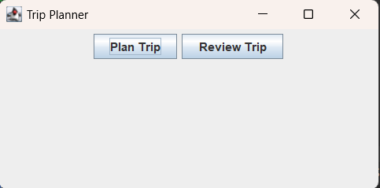

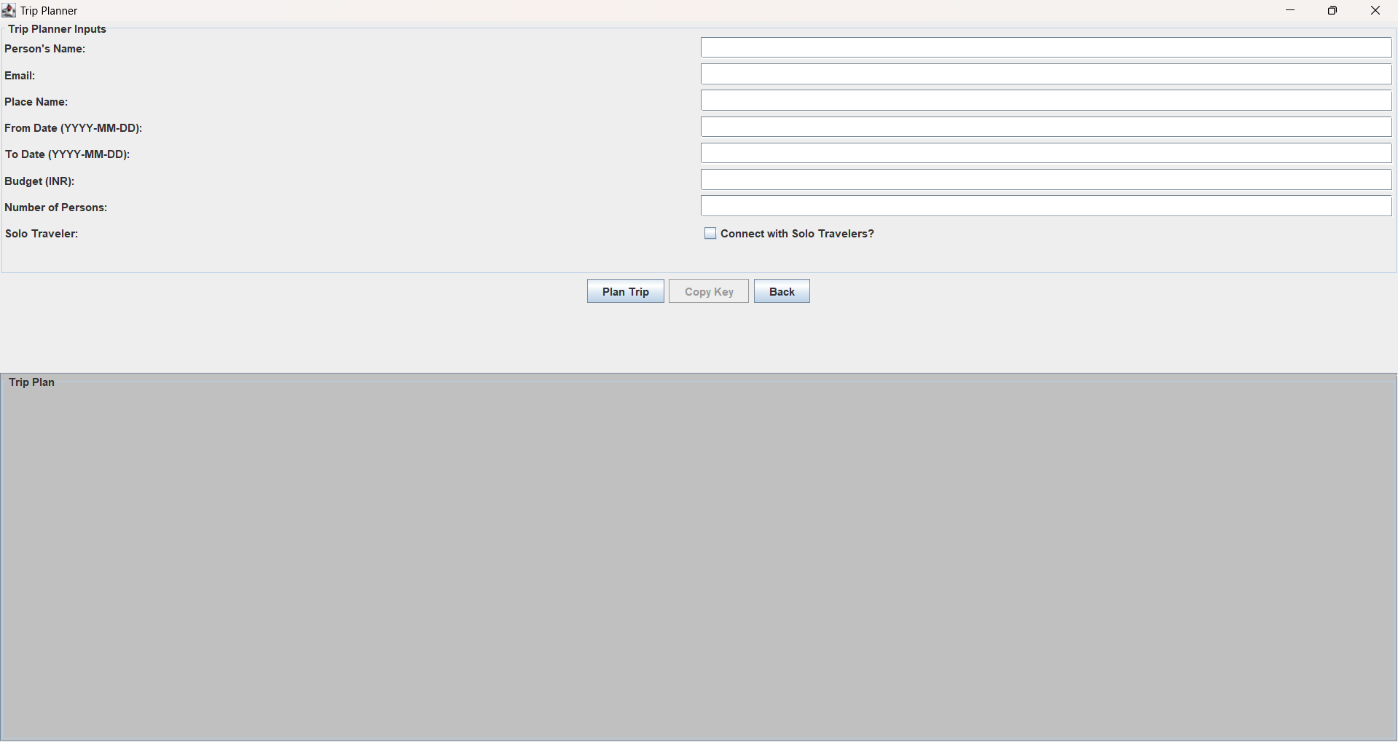

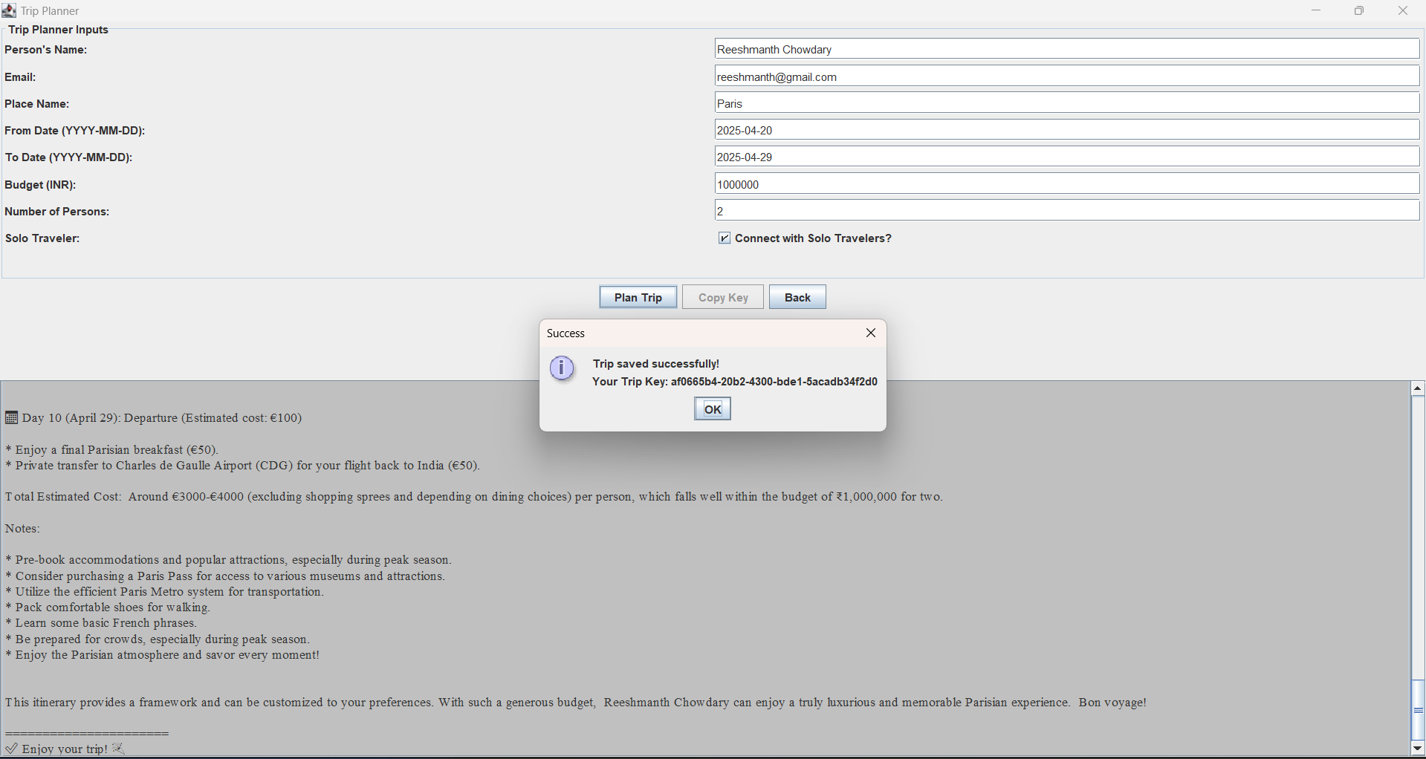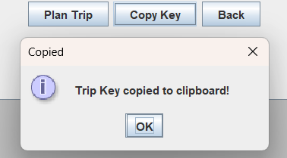 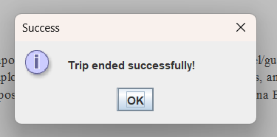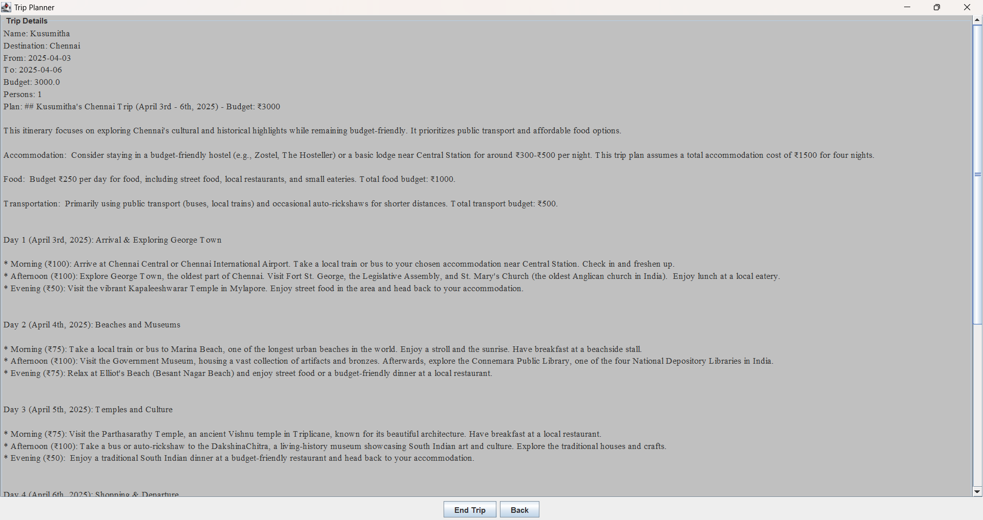

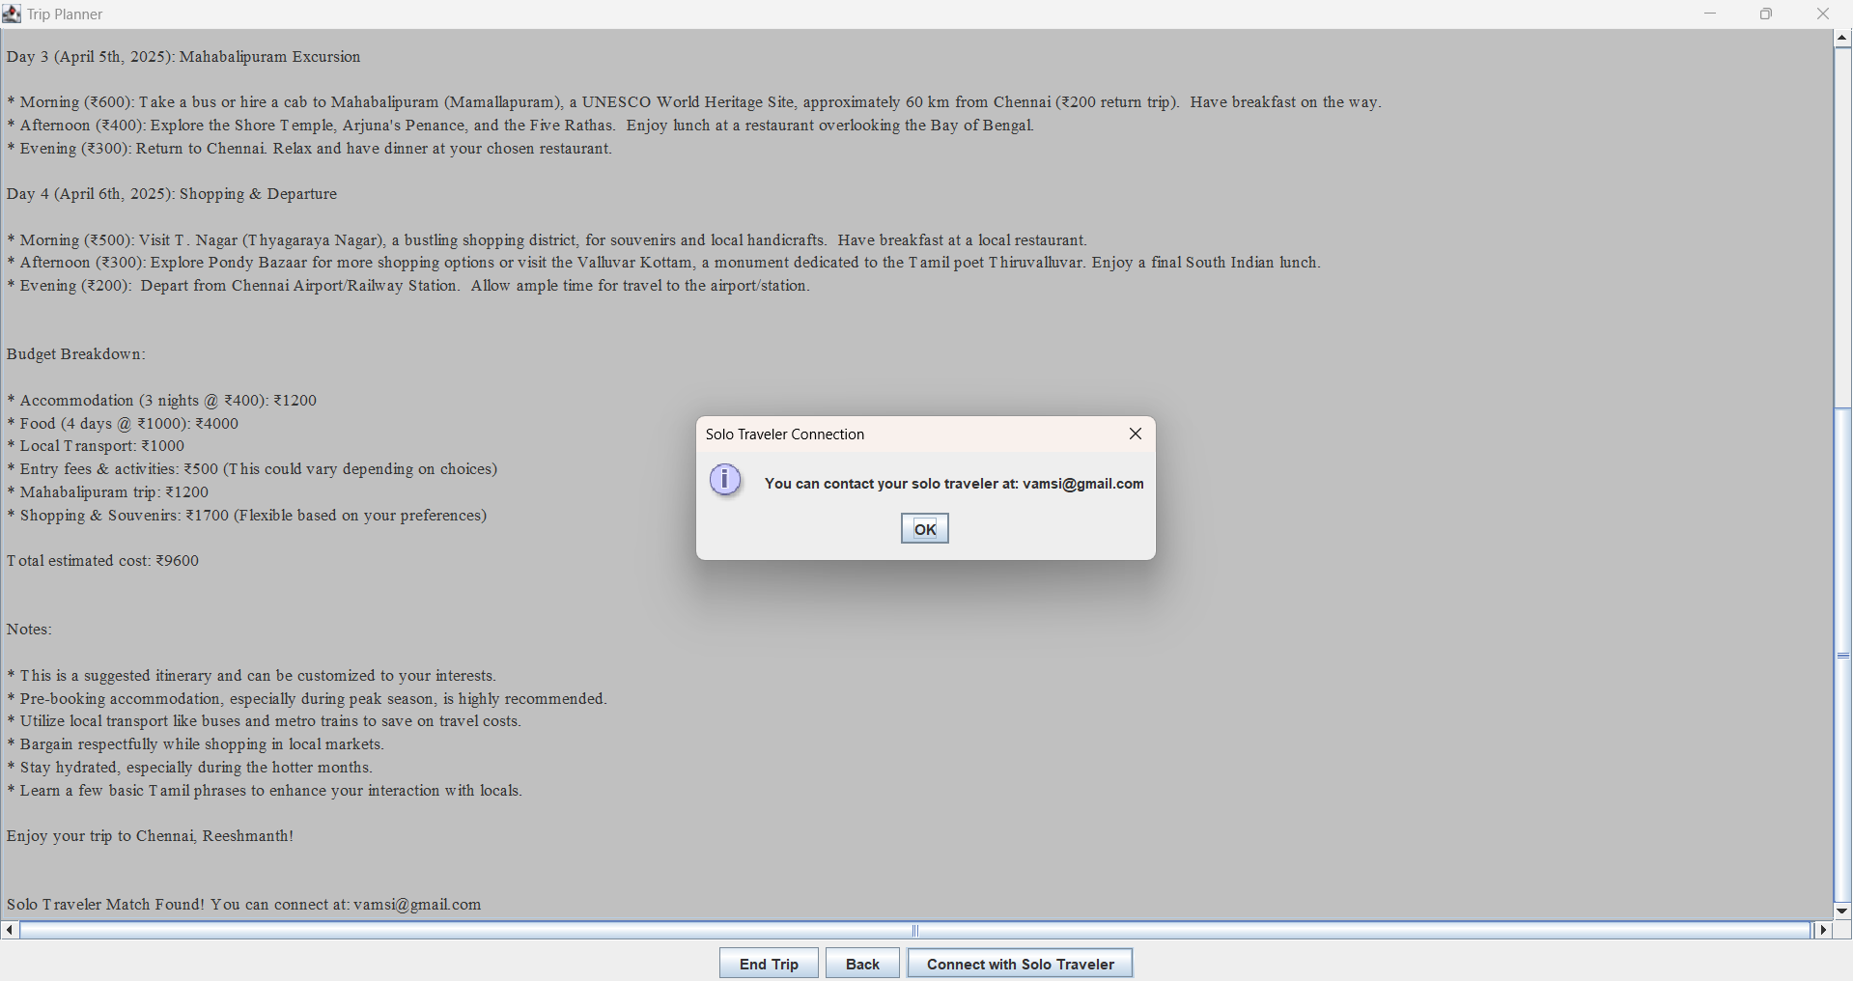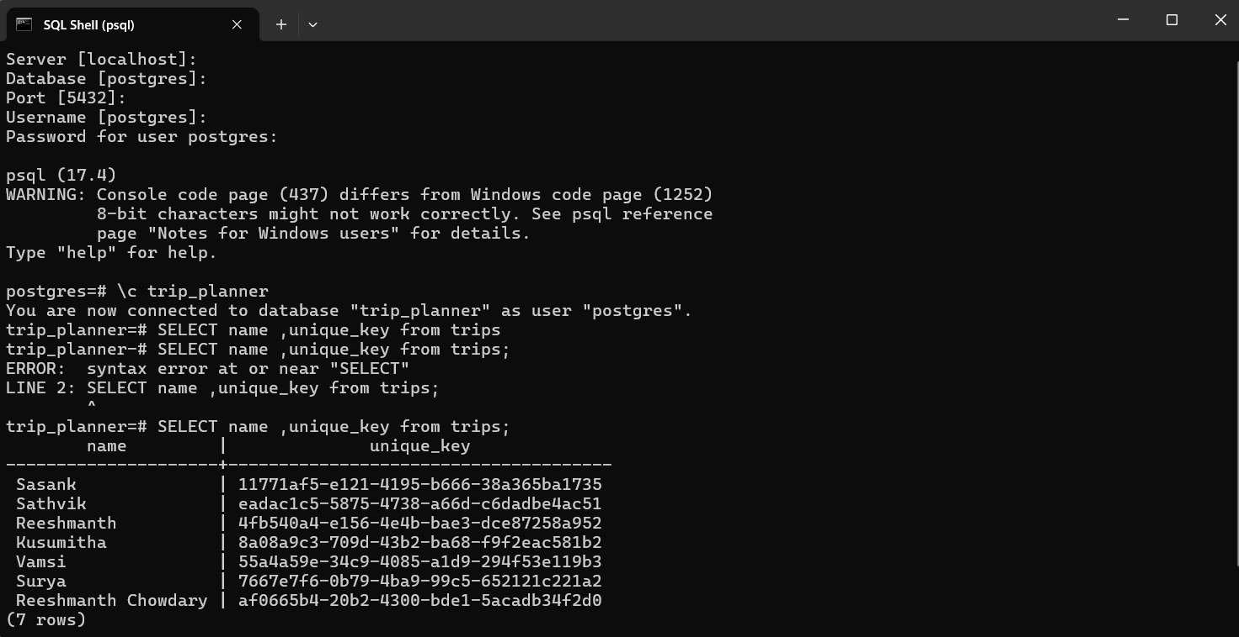

1. **CONCLUSION & FUTURE SCOPE**

**Conclusion:**

The AI-based Trip Planner is a comprehensive solution designed to help travelers plan their trips by integrating Gemini AI for generating detailed itineraries based on user inputs. The system supports personalized trip planning, allowing users to select destinations, dates, and other preferences such as budget and the number of people. The inclusion of features like solo traveler connectivity, where users can connect with others traveling to the same destination, further enhances the travel experience.

The system is well-structured with a user-friendly GUI built using Java Swing, enabling smooth interaction between the user and the backend components. The integration with a PostgreSQL database ensures efficient management of user data, trip details, and matching solo travelers.

**Key highlights of the solution include:**

* A well-designed UI for input collection and trip plan review.
* API integration with Gemini AI to generate customized trip plans.
* Database support for saving and managing trip details.
* Solo traveler matching feature to foster community connections.

The combination of these features makes the AI Trip Planner a powerful tool for solo and group travelers looking for personalized travel experiences.

**Future Scope:**

While the current implementation is effective, there are a few key areas for future development:

1. **Enhanced AI Capabilities**: Further refinement of the AI model to include more personalized travel preferences such as travel style, accommodation types, and activity suggestions.
2. **Mobile Application**: Developing a mobile version of the app to provide users with a more convenient way to plan and manage their trips on-the-go.
3. **Payment Integration**: Adding payment gateways to allow users to book and pay for their trips directly through the platform.
4. **Social Features**: Integrating social media sharing capabilities and enhancing the solo traveler matching feature to improve community connections.
5. **Multi-language and Multi-currency Support**: Expanding the platform to support multiple languages and currencies for a broader, international audience.

**References**

1. **GeeksforGeeks - *Java Programming Language***
2. **"Java: The Complete Reference" by Herbert Schildt - *A thorough guide to learning Java from the basics to advanced topics*Wikipedia - *Java (Programming Language)***
3. **Wikipedia - *Swing (Java)***[**https://en.wikipedia.org/wiki/Swing_(Java)**](https://en.wikipedia.org/wiki/Swing_(Java))
4. **Oracle - *Java SE Documentation***[**https://docs.oracle.com/javase/8/docs/**](https://docs.oracle.com/javase/8/docs/)
5. **Baeldung - *JDBC Tutorials***[**https://www.baeldung.com/java/jdbc**](https://www.baeldung.com/java/jdbc)
6. **Spring Framework - *Official Spring Framework Documentation***[**https://spring.io/projects/spring-framework**](https://spring.io/projects/spring-framework)
7. **Gemini API Documentation (For integrating Gemini AI in your project)**[**https://www.gemini.com/api**](https://www.gemini.com/api)
8. **Stack Overflow - *Java Development Community Questions & Answers***[**https://stackoverflow.com/questions/tagged/java**](https://stackoverflow.com/questions/tagged/java)
9. **ChatGPT - *AI Tools for Developers***[**https://openai.com/chatgpt**](https://openai.com/chatgpt)
10. **"Design Patterns: Elements of Reusable Object-Oriented Software" by Erich Gamma, Richard Helm, Ralph Johnson, John Vlissides - *A classic book on design patterns in object-oriented software***
11. **"Head First Design Patterns" by Eric Freeman and Elisabeth Robson - *A beginner-friendly book on understanding design patterns in Java***